1.Data Model Diagram
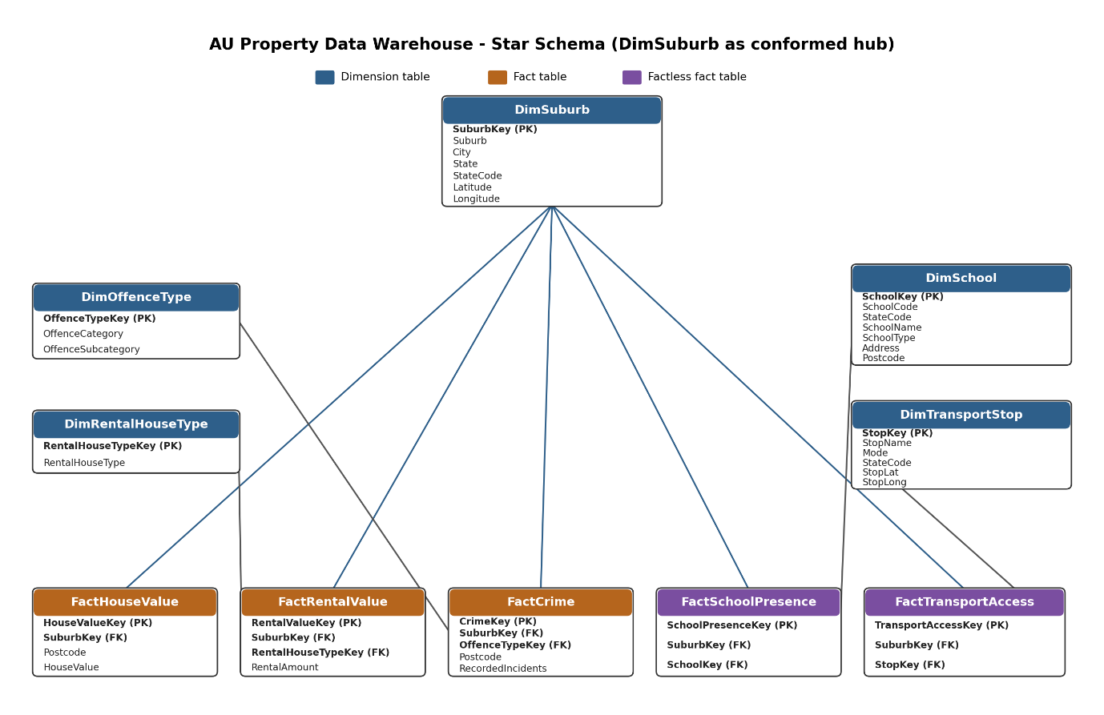
2.SSIS Package Designs for Dimensional Loading
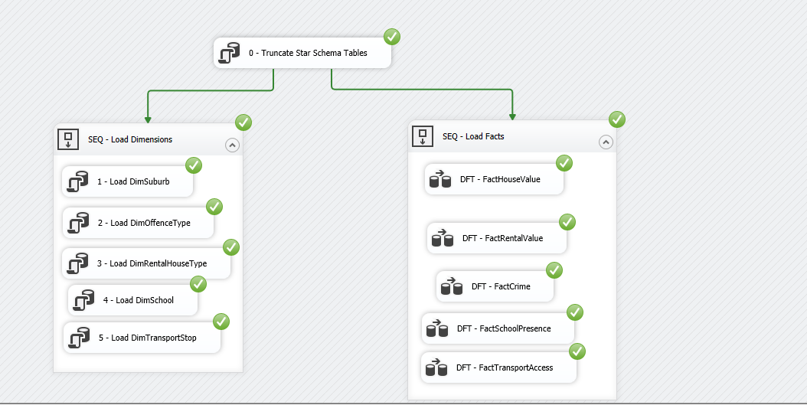

3.Sample data in Dimension and fact tables
Row Count:
SELECT 'star.DimSuburb' AS TableName, COUNT(*) AS Rows FROM star.DimSuburb
UNION ALL SELECT 'star.DimOffenceType', COUNT(*) FROM star.DimOffenceType
UNION ALL SELECT 'star.DimRentalHouseType', COUNT(*) FROM star.DimRentalHouseType
UNION ALL SELECT 'star.DimSchool', COUNT(*) FROM star.DimSchool
UNION ALL SELECT 'star.DimTransportStop', COUNT(*) FROM star.DimTransportStop
UNION ALL SELECT 'star.FactHouseValue', COUNT(*) FROM star.FactHouseValue
UNION ALL SELECT 'star.FactRentalValue', COUNT(*) FROM star.FactRentalValue
UNION ALL SELECT 'star.FactCrime', COUNT(*) FROM star.FactCrime
UNION ALL SELECT 'star.FactSchoolPresence', COUNT(*) FROM star.FactSchoolPresence
UNION ALL SELECT 'star.FactTransportAccess', COUNT(*) FROM star.FactTransportAccess;
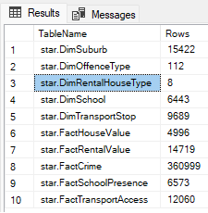

Rows fell back to the Unknown suburb member (-1):
SELECT 'FactHouseValue' AS FactTable, COUNT(*) AS UnknownSuburbRows FROM star.FactHouseValue WHERE SuburbKey = -1
UNION ALL SELECT 'FactRentalValue', COUNT(*) FROM star.FactRentalValue WHERE SuburbKey = -1
UNION ALL SELECT 'FactCrime', COUNT(*) FROM star.FactCrime WHERE SuburbKey = -1
UNION ALL SELECT 'FactSchoolPresence', COUNT(*) FROM star.FactSchoolPresence WHERE SuburbKey = -1
UNION ALL SELECT 'FactTransportAccess', COUNT(*) FROM star.FactTransportAccess WHERE SuburbKey = -1;
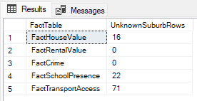
Average house value AND crime incident count by state:
SELECT s.State,
AVG(hv.HouseValue) AS AvgHouseValue,
SUM(cr.RecordedIncidents) AS TotalRecordedIncidents,
COUNT(DISTINCT sp.SchoolKey) AS SchoolCount,
COUNT(DISTINCT ta.StopKey) AS TransportStopCount
FROM star.DimSuburb s
LEFT JOIN star.FactHouseValue hv ON hv.SuburbKey = s.SuburbKey
LEFT JOIN star.FactCrime cr ON cr.SuburbKey = s.SuburbKey
LEFT JOIN star.FactSchoolPresence sp ON sp.SuburbKey = s.SuburbKey
LEFT JOIN star.FactTransportAccess ta ON ta.SuburbKey = s.SuburbKey
WHERE s.SuburbKey <> -1
GROUP BY s.State
ORDER BY s.State;
GO
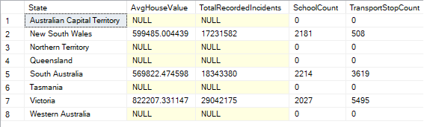

Key ETL transformations

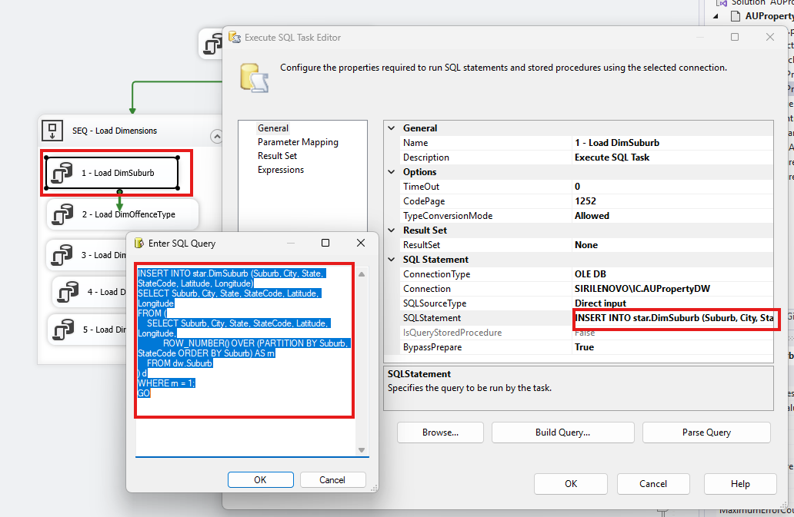
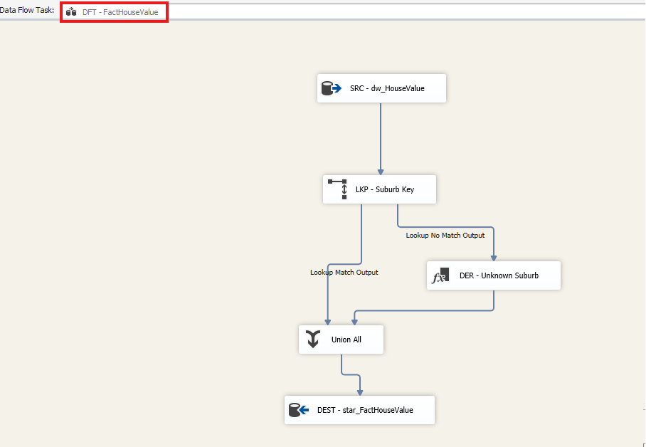
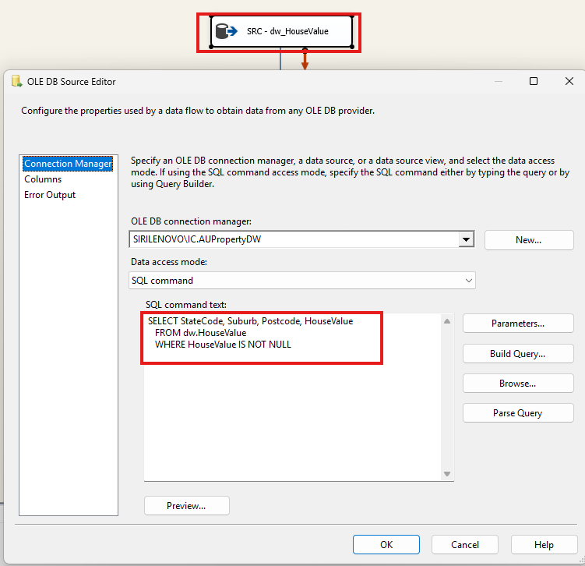
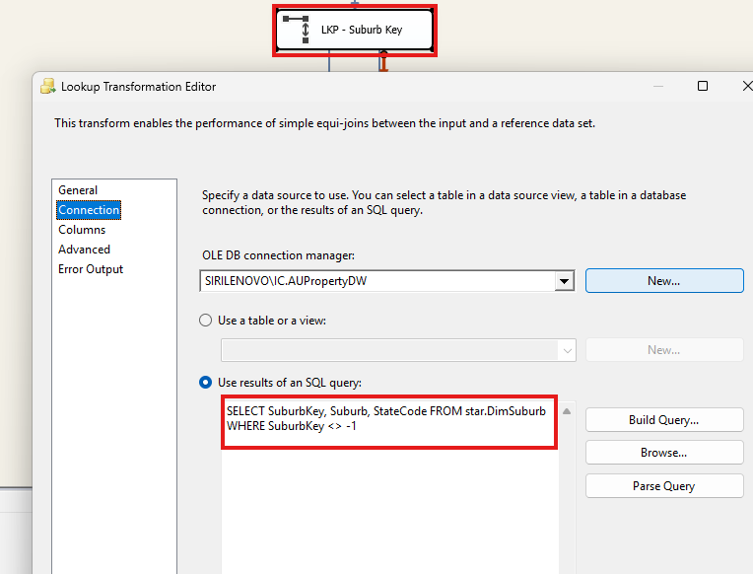
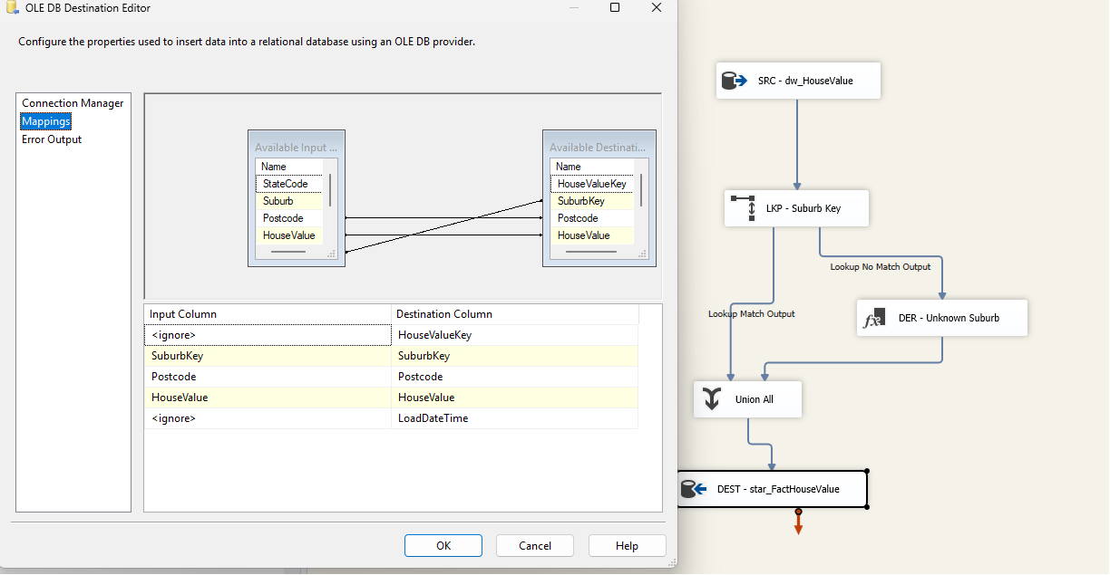
I took one example from each sequence table and attached the screen shots.

